* Type s3 in the search bar of amazon  
    
  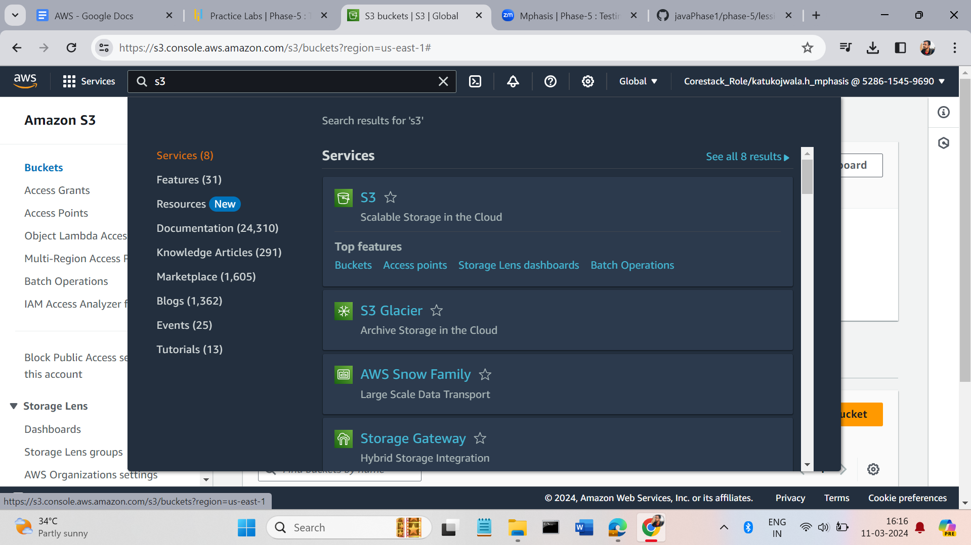
* Click on the buckets and click the create bucket button right side of the window. Enter the details.  
    
  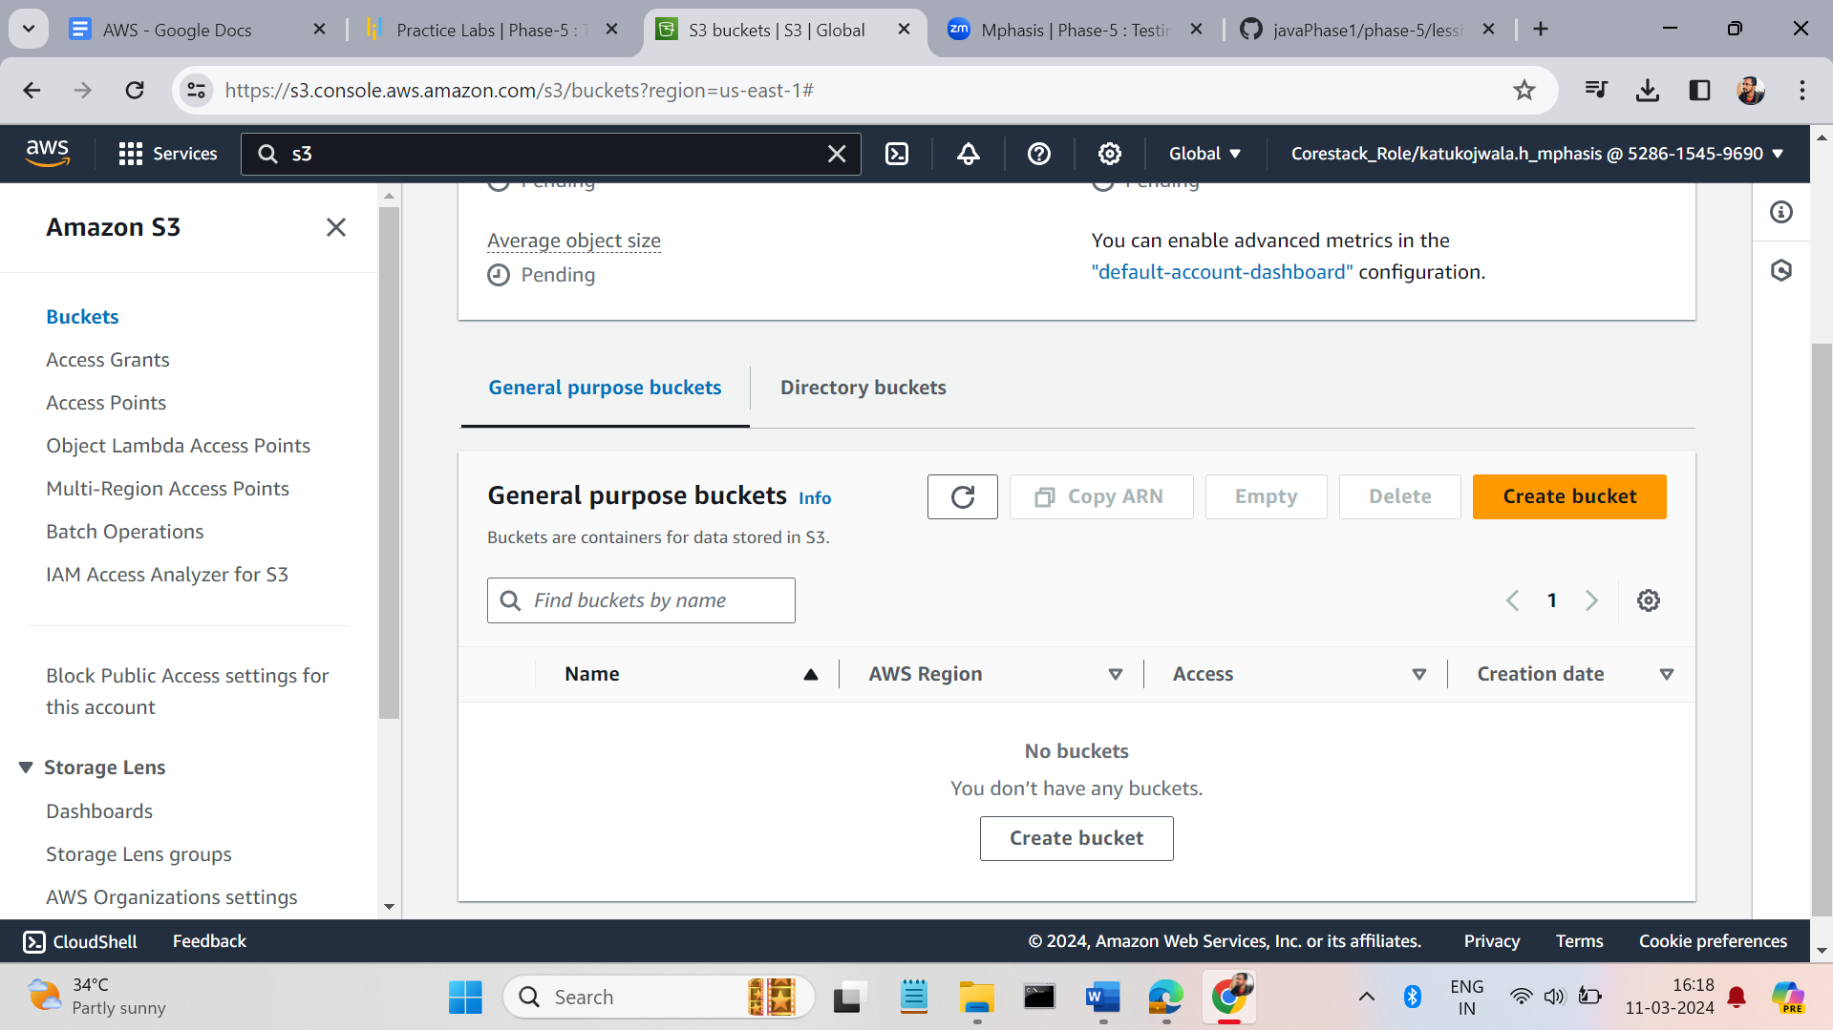  
    
    
    
    
    
  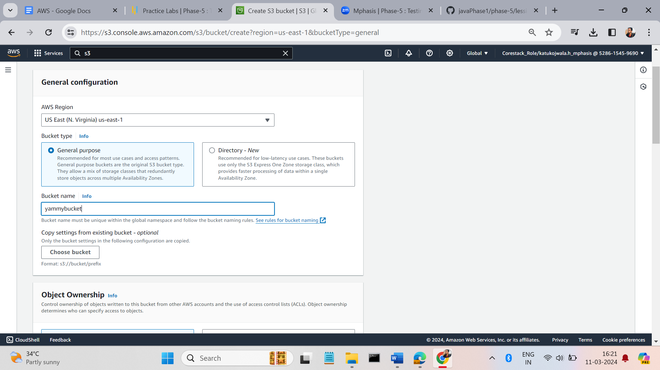
* At the bottom we have an option like create bucket. Click on that it creates a bucket. (The name must be unique).  
    
  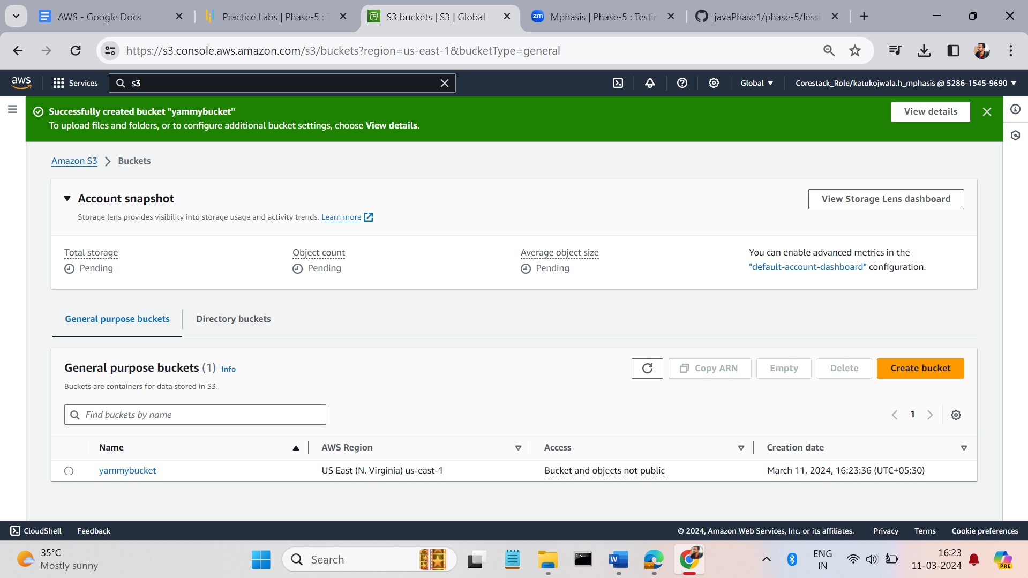  
    
    
    
    
    
    
    
  we can upload the files by clicking on the button add files or add folder. On right side of the session.

